

**Semester One**

**Examination 2023**

**Marking Guide**

**Physical Education Studies**

**Units 1&2**

Name: _______________________________________________________

Teacher: ___________________________________________________

***TIME ALLOWED FOR THIS PAPER***

Reading time before commencing work: Ten minutes

Working time for the paper: Two and half hours

***MATERIALS REQUIRED/RECOMMENDED FOR THIS PAPER***

**To be provided by the supervisor:**

* This Question/Answer Booklet

**To be provided by the candidate:**

* Standard items: pens, pencils, eraser or correction fluid, ruler, highlighter.
* Special items: Calculators satisfying the conditions set by the SCSA for this subject.

***IMPORTANT NOTE TO CANDIDATES***

No other items may be taken into the examination room. It is **your** responsibility to ensure that you do not have any unauthorised notes or other items of a non-personal nature in the examination room. If you have any unauthorised material with you, hand it to the supervisor **before** reading any further.

**Structure of this paper**

|  |  |  |  |  |  |
| --- | --- | --- | --- | --- | --- |
| Section | Number of questions available | Number of questions to be answered | Suggested working time  (minutes) | Marks available | Percentage of exam |
| Topic One:  Multiple Choice | x | x | 30 | x | 20 |
| Section Two:  Short answer | x | x | 70 | x | 50 |
| Section Three:  Extended answer | x | x | 50 | x | 30 |
|  |  |  | **Total** | x | 100 |

**Instructions to candidates**

1. The rules for the conduct of Western Australian external examinations are detailed in the *Year 11 Information Handbook 2017.* Sitting this examination implies that you agree to abide by these rules.
2. Write your answers in this Question/Answer Booklet.

Answer all questions according to the following instructions.

Multiple-Choice: Answer **all** questions on the separate Multiple-choice Answer Sheet provided. For each question shade the box to indicate your answer. Use only a blue or black pen to shade the boxes. If you make a mistake, place a cross through that square, do not erase or use correction fluid, and shade your new answer. Marks will not be deducted for incorrect answers. No mark will be given if more than one answer is completed for any reason.

Short Answer and Extended Answer: Write answers to in this Question/Answer Booklet.

1. You must be careful to confine your responses to the specific questions asked and follow any instructions that are specific to a particular question.
2. Spare pages are included at the end of this booklet. They can be used for planning your responses and/or as additional space if required to continue an answer.
   * Planning: If you use the spare pages for planning, indicate this clearly.
   * Continuing an answer: If you need to use the space to continue an answer, indicate in the original answer space where the answer is continued, i.e. give the page number. Refer to the question(s) where you are continuing your work.

**Topic: Functional Anatomy (35 marks)**

This section has **10** questions. Answer **all** questions. Answer the five **(5)** Multiple-Choice questions on the separate Multiple-choice answer Sheet provided. Write your answers to the Short Answer and Extended Answer question in the spaces provided in this Question/Answer Booklet. Wherever possible, confine your answers to the line spaces provided. Use a blue or black pen (**not** pencil) for this section.

Spare pages are included at the end of this booklet. They can be used for planning your responses and/or as additional space if required to continue an answer.

Suggested working time: 50 minutes.

**Multiple Choice (5 marks)**

1. Which blood vessel would only carry deoxygenated blood?
2. Vena cava.
3. Aorta.
4. Pulmonary vein.
5. Capillaries.
6. Which muscle contracts to bring the knee closer to the chest during a tuck somersault?
7. Quadricep.
8. Hamstring.
9. Hip flexors.
10. Gastrocnemius.
11. The insertion point for the hamstring muscle is located on the:
12. Tibia.
13. Femur.
14. Patella.
15. Tarsals.
16. Turning the palm upwards to catch a falling cricket ball would be described as:
17. Pronation.
18. Flexion.
19. Extension.
20. Supination.
21. Diffusion of oxygen into the blood stream will occur in the:
22. Bronchioles.
23. Alveoli.
24. Lungs.
25. Diaphragm.

**Short Answer (20 marks)**

**Question 6 (5 marks)**

The heart pumps blood throughout the circulatory system to deliver oxygen to the working muscles.

(a) Identify what type of involuntary muscle the heart is. (1 mark)

|  |  |
| --- | --- |
| **Answer** | **Max 1 Mark** |
| Cardiac muscle | 1 mark |

(b) Identify the chamber of the heart into which freshly oxygenated blood enters. (1 mark)

|  |  |
| --- | --- |
| **Answer** | **Max 1 Mark** |
| Left Atrium | 1 mark |

(c) Identify the blood vessel that transports deoxygenated blood from the heart to the lungs.

(1 mark)

|  |  |
| --- | --- |
| **Answer** | **Max 1 Mark** |
| Pulmonary Artery | 1 mark |

(d) Delivering oxygen and removing waste are two major functions of blood. Outline **two** other functions of blood.

(2 marks)

|  |  |
| --- | --- |
| **Answer Description (no mark for identification only)** | **Max 2 Marks** |
| **Protection**  White blood cells fight disease / bacteria (no mark for identifying protection) | 1 mark |
| **Temperature Regulation**  Blood vessels either dilate or constrict to allow blood to cool or retain heat (no mark for identifying temperature regulation) | 1 mark |

**Question 7 (5 marks)**

Joints enable movement in a variety of planes for optimal sporting performance. Complete the table below to demonstrate your understanding of different movement types.

|  |  |  |
| --- | --- | --- |
| **Movement Type** | **Answer Description / Definition** | **Max 5 Marks** |
| Flexion | The closing of a joint / decreasing the angle of a joint (or similar) | 1 mark |
| **Abduction** | Moving a limb away from the mid-line of the body | 1 mark |
| Circumduction | The movement of a joint or limb in a cone / conical / circular shaped motion (or similar) | 1 mark |
| **Dorsi flexion** | Moving the toes upwards towards the tibialis anterior | 1 mark |
| Pronation | The turning of the palm to face downwards (or similar) | 1 mark |

**Question 8 (4 marks)**

Muscles are attached to bones by soft tissues known as tendons at either end which pull upon the bone to create movement.

(a) Define the terms ‘origin’ and ‘insertion’, in relation to points of muscles. (2 marks)

|  |  |
| --- | --- |
| **Answer Description** | **Max 2 Marks** |
| **Origin:** The point the muscle attaches to the stationary (proximal) bone (or similar) | 1 mark |
| **Insertion:** The point the muscle attaches to the moving (distal) bone (or similar) | 1 mark |

(b) Identify the agonist and antagonist muscles of the Australian Football player when executing the drop punt.

(2 marks)

|  |  |
| --- | --- |
| **Answer Description (must be correctly correlated, not just listed)** | **Max 2 Marks** |
| **Agonist:** Quadriceps | 1 mark |
| **Antagonist:** Hamstring | 1 mark |

**Question 9 (6 marks)**

Gymnasts, in order to avoid injury, train by stretching their muscles beyond normal resting length. This increases the muscles extendibility.

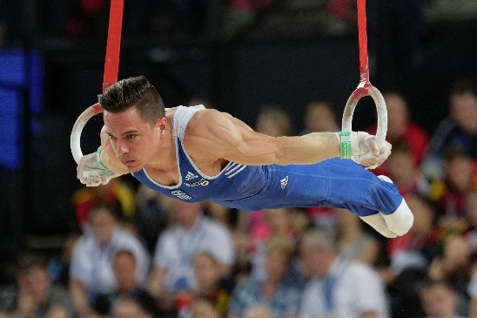

Identify and define the **three** other characteristics of skeletal muscle.

|  |  |
| --- | --- |
| **Answer Description** | **Max 6 Marks** |
| **Identifies** Contractibility  **Defines:** The ability of a muscle to shorten or reduce in length (or similar) | 1 mark  1 mark |
| **Identifies** Excitability  **Defines:** The ability of a muscle to contract in response to a stimulus or nerve impulse from the central nervous system (or similar) | 1 mark  1 mark |
| **Identifies** Elasticity  **Defines:** The ability of a muscle to return back to its original resting length after being stretched (or similar) | 1 mark  1 mark |

**Extended Answer (10 marks)**

**Question 10** (10 marks)

In 2021, Western Australian Peter Bol became a household name after narrowly missing out on a medal at the Tokyo Olympics, placing 4th in the 800m final. During qualifying he ran an Australian national record of 1min 44.11secs. Explain the mechanics of breathing that would have occurred during Peter Bol’s 800m race.

|  |  |
| --- | --- |
| **Answer Description (Maximum of 2 marks only for identification)** | **10 Marks Max** |
| **Identifies** inspiration (or inhalation) as the process of breathing in  **Identifies** expiration (or exhalation) as the process of breathing out | **Max 2 Marks**  1-2 marks |
| **Inspiration (Inhalation)**  Diaphragm muscle contracts or flattens  Thoracic cavity (rib cage) expands, moves upwards/outwards  Increase in lung volume/size  Air pressure in lungs decreases (lower air pressure)  Air is drawn into lungs due to pressure differential (higher external air pressure moves to lower internal pressure) | **Max 4 Marks**  1-4 marks |
| **Expiration (Exhalation)**  Diaphragm muscle relaxes or rises  Pleural cavity contracts  Decrease in lung volume/size  Air pressure in lungs increases (higher air pressure)  Air is pushed out of the lungs to pressure differential | **Max 4 Marks**  1-4 marks |

**End of Topic**

**Topic: Exercise Physiology (35 marks)**

This section has **9** questions. Answer **all** questions. Answer the five **(5)** Multiple-Choice questions on the separate Multiple-choice answer Sheet provided. Write your answers to the Short Answer and Extended Answer question in the spaces provided in this Question/Answer Booklet. Wherever possible, confine your answers to the line spaces provided. Use a blue or black pen (**not** pencil) for this section.

Spare pages are included at the end of this booklet. They can be used for planning your responses and/or as additional space if required to continue an answer.

Suggested working time: 50 minutes.

**Multiple Choice (5 marks)**

* + - 1. Which of the following would be an acute response to physical activity?

1. Decreased resting heart rate.
2. Increased capillarisation.
3. Increased maximal heart rate.
4. Perspiration.
   * + 1. High Glycaemic Index (GI) food sources are most appropriate for athletes to:
          1. provide muscles with a rapid source of energy immediately prior and during competition.
          2. increase glycogen stores in the muscle and liver.
          3. improve efficiency of the aerobic energy system during short intervals.
          4. provide muscles with a sustained release of energy during competition.
       2. When compiling a training program, which component of fitness would be of most importance to a 100m sprinter?
          1. Cardiorespiratory endurance.
          2. Agility.
          3. Speed.
          4. Muscular strength.
       3. Which method of training would be most appropriate for a basketball point guard?
5. Short interval training.
6. Continuous training.
7. Plyometrics.
8. Resistance training.
   * + 1. The predominant energy system utilised during the Long Jump in athletics would be:
9. Lactic Acid.
10. ATP-CP.
11. Aerobic.
12. Inter-play of all three energy systems.

**Short Answer (20 marks)**

**Question 6 (8 marks)**

CrossFit has recently become a popular recreational training activity for personal fitness. The CrossFit Games incorporates a variety of demanding exercises which require different training methods and muscular contractions.

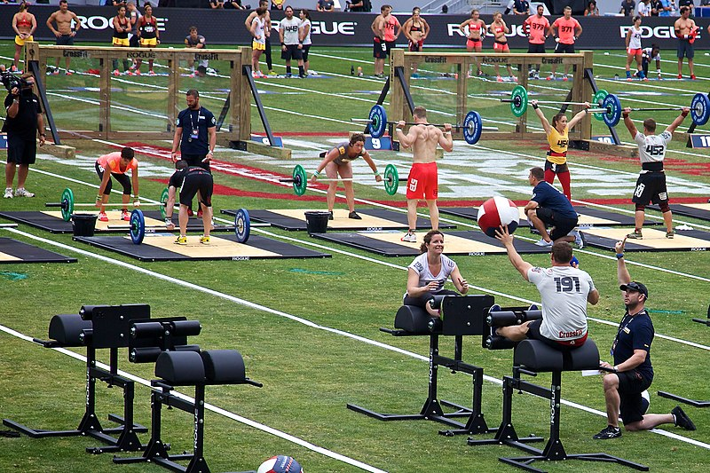

1. Identify thetraining type that would benefit explosive movements which are often required at the CrossFit Games. (1 Mark)

|  |  |
| --- | --- |
| **Identifies** | **1 Mark** |
| Plyometrics | 1 mark |

1. Explosive movements can often cause injuries to soft tissues such as ligaments, tendons and muscles. Define which training method should be incorporated to lower the risk of injury and provide an example for a CrossFit athlete. (3 Marks)

|  |  |
| --- | --- |
| **Answer Description** | **Max 3 Marks** |
| **Identifies:** Flexibility training  **Defines:** Increasing the range of motion at a joint  **Example:** Leg swings prior to competing to increase flexibility and range of motion at hips and stretch the hamstring muscle to avoid a tear.  **(Accept any other relevant example to reduce injury risk)** | 1 mark  1 mark  1 mark |

1. CrossFit requires muscular contractions that differ between the exercise being executed. Outline the **two** types of muscular contractions necessary for the following movements.

(4 Marks)

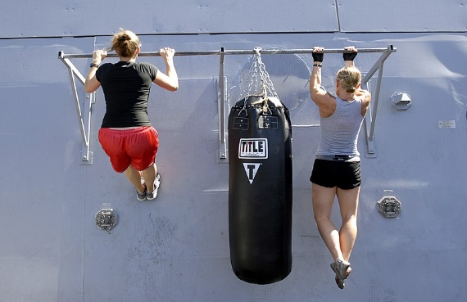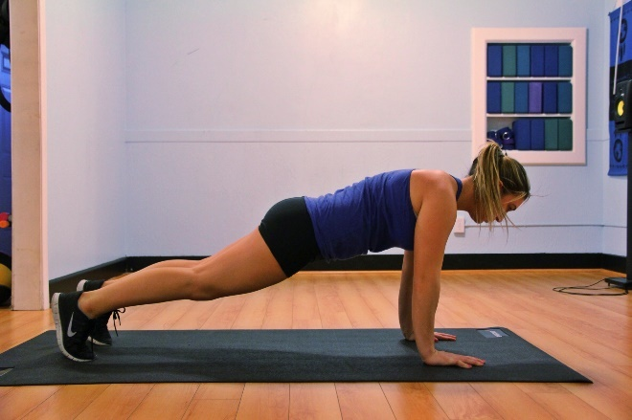

**Plank Pull Ups**

|  |  |
| --- | --- |
| **Answer Description** | **Max 4 Marks** |
| **Plank:** Isometric Contraction  **Defines:** Muscle length remains constant/static/the same during contraction.  **Pull Up:** Isotonic Contraction  **Defines:** Muscle length changes/shortens/lengthens during contraction. | 1 mark  1 mark  1 mark  1 mark |

**Question 7 (7 marks)**

The marathon is an endurance event run over a distance of 42.2km. Elite athletes will take between 2 - 2½ hours to complete the distance.

(a) Identify the predominant energy system when competing in a marathon. (1 mark)

|  |  |
| --- | --- |
| **Answer** | **1 Mark** |
| Aerobic Energy System | 1 mark |

(b) In order to compete for 2 - 2½ hours at optimal performance, athletes must consider their nutritional requirements prior to competition. Describe how a marathon runner would utilise their different energy sources to fuel themselves throughout the race.

(6 marks)

|  |  |
| --- | --- |
| **Answer Description (Maximum of 3 marks for identifying only)** | **Max 6 Marks** |
| **Carbohydrates** (Primary energy source)  Most efficient energy source to breakdown ATP at sustained higher intensity exercise (e.g. marathon running; not sprinting/walking)  Sugars and starches such as bread, cereals, pasta are muscles preferred (primary) source of fuel during exercise (stored in muscle and liver).  Possible carbohydrate loading strategy to supplement glycogen stores in muscle and liver (days/week leading into competition) to delay glycogen depletion/fatigue. | 1 mark  1 mark |
| **Low Glycaemic Index Foods**  Consume slow-release foods that break down slowly and release energy gradually for sustained energy release. Released into blood stream gradually to raise blood sugar.  Should be consumed as pre-event meal 2-4 hours prior to marathon. | 1 mark  1 mark |
| **Fats** (Secondary energy source)  Only used in marathon when carbohydrates are depleted. Exercise intensity (e.g. pace) will be reduced due to slower breakdown of fats to produce ATP.  Act as concentrated fuel storage in adipose tissue such as butter, margarine, oils, fatty meats providing the body’s preferred fuel at rest and during prolonged periods of submaximal exercise or resting (not competing). | 1 mark  1 mark |
| **Protein** (Last resort)  Little to no contribution to energy production unless in carbohydrates and fats are fully depleted. Ultra-endurance events only (unlikely in elite marathon).  Predominantly enzymes and amino acids used for growth and repair only. | 1 mark  1 mark |
| **High Glycaemic Index Foods**  Consume fast-release foods that break down (digested) quickly and release energy immediately for a short energy release. Released into blood stream quickly to raise blood sugar and produce, rapid absorption .  Should be consumed as pre-event snack 15 minutes prior to competing and at intervals during race to delay glycogen depletion in muscles and liver such as lollies, sports drinks, energy gels. | 1 mark  1 mark |

**Question 8 (5 marks)**

During the Australian Rules Football pre-season, players incrementally improve their aerobic conditioning to prepare for the rigour and stress which will be placed on their physiological systems during the season.

1. Identify the principle of training players will apply to increase their fitness during pre-season. (1 Mark)

|  |  |
| --- | --- |
| **Answer** | **1 Mark** |
| Progressive Overload | 1 mark |

1. Identify and define **two** variables Australian Rules Football players can increase to place added stress upon the physiological systems to cause adaptations. (4 Marks)

|  |  |
| --- | --- |
| **Answer Description (1 mark only for identification)** | **Max 6 Marks** |
| **Frequency**  Increase ‘how often’ the player trains. e.g. training sessions per day / per week.  **Intensity**  Increase ‘how hard’ the player trains. e.g. increase speed, distance, weights lifted, repetitions, sets, less rest/recovery between intervals.  **Duration (Time)**  Increase ‘how long’ the player trains. e.g. longer training sessions, longer distance. | 1 mark  1 mark  1 mark  1 mark  1 mark  1 mark |

**Extended Answer (10 marks)**

**Question 9 (10 marks)**

In 2022, Jai Hindley made history as the first Australian cyclist to win the three-week Giro d’Italia Grand Tour. Each stage ranged from 120km to over 200km, taking up to 6 hours in length to complete. Jai’s endurance has been extensively trained to endure the stress of competition since the weekly Perth river loops and hills training rides that he used to complete as a junior.

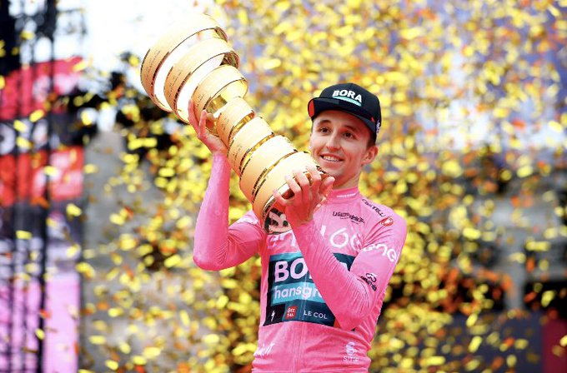

Using your knowledge of the long term cardiovascular and respiratory effects of training, discuss **five** chronic adaptations Jai would have developed as a result of his training to be able to compete at his optimal performance state.

|  |  |
| --- | --- |
| **Answer Description**  **1 mark for correct identification, must include increase/decrease (max 5 marks)**  **1 mark for correct application to endurance optimal performance (max 5 marks)** | **Max 10 Marks** |
| **Increased cardiac hypertrophy**  Size of the heart increases, cardiac muscle strengthens, left ventricle wall thickens which allows more blood to be pumped with each beat (stroke volume) to deliver oxygenated blood to working muscles to avoid lactic acid accumulation or fatigue. | 1 mark  1 mark |
| **Decreased resting heart rate or increased maximal heart rate**  As the cardiac muscle (heart) is strengthened it becomes more efficient. At rest or lower intensities (e.g. flat stages) the heart can still pump enough oxygen to working muscles in a single beat with a lower heart rate (bpm) necessary.  At higher intensities (e.g. time trials, mountain stages), the cardiac muscle (heart) has the increased capacity to pump more blood per beat at a higher heart rate (bpm) to provide oxygen to working muscles and avoid lactic acid accumulation. | 1 mark  1 mark |
| **Increased stroke volume**  The amount of blood pumped in one beat form the left ventricle (into aorta) is increased to supply adequate oxygen to working muscles to maintain use of the aerobic system. | 1 mark  1 mark |
| **Increased blood volume or haemoglobin levels**  Red blood cell count increase results in more haemoglobin which carries/attaches to oxygen being able to be carried/transported and delivered to working muscles when required. | 1 mark  1 mark |
| **Increased capillarisation**  Increased size, density and/or number of capillaries at the lungs (alveoli) and/or muscle bed to diffuse and supply oxygen to the working muscles and remove waste (CO2 or lactic acid) as necessary. | 1 mark  1 mark |
| **Decreased blood pressure**  Due to increased efficiency of heart cardiac muscle, arteries (increased elasticity) and capillarisation the circulatory system blood flow is more efficient | 1 mark  1 mark |
| **Increased oxygen exchange or diffusion**  Increased oxygen into blood stream at capillaries in the lungs (alveoli) and/or muscle bed to diffuse and supply oxygen to the working muscles and remove waste (CO2 or lactic acid) as necessary. | 1 mark  1 mark |
| **Increased maximal oxygen uptake (VO2 max)**  The volume of oxygen that can be inhaled and delivered/utilised at the muscle bed to maintain the aerobic system before lactic acid begins to accumulate causing fatigue. | 1 mark  1 mark |
| **Increased ventilation capacity / tidal volume**  More oxygen can be inspired in a single breath (increased tidal volume) meaning a lower respiratory/ventilation rate (breaths per minute) resulting in an increased efficiency of oxygen into the lungs to be diffused to the bloodstream. Stronger respiratory muscles (diaphragm and intercostals) | 1 mark  1 mark |
| **Allow any other relevant adaptation to training identified and applied** |  |

**End of Topic**

**Topic: Biomechanics (35 marks)**

This section has **9** questions. Answer **all** questions. Answer the five **(5)** Multiple-Choice questions on the separate Multiple-choice answer Sheet provided. Write your answers to the Short Answer and Extended Answer question in the spaces provided in this Question/Answer Booklet. Wherever possible, confine your answers to the line spaces provided. Use a blue or black pen (**not** pencil) for this section.

Spare pages are included at the end of this booklet. They can be used for planning your responses and/or as additional space if required to continue an answer.

Suggested working time: 50 minutes.

**Multiple Choice (5 marks)**

1. In golf, the pin (hole) can be higher than the tee off shot. Which angle of projection would seem the most accurate for a tee off shot in this circumstance?
2. 20 degrees.
3. 45 degrees.
4. 65 degrees.
5. 90 degrees.
6. A 50m freestyle swimmer would be best describe as having which type of motion?
7. Linear motion
8. General motion
9. Angular motion
10. Projectile motion
11. Ricky Ponting, former Australian Test Captain, was famed for his attacking cricket pull shot. A cricket pull shot is best performed using a:
12. simultaneous movement to produce maximum accuracy.
13. simultaneous movement to produce maximum force.
14. sequential movement to produce maximum accuracy.
15. sequential movement to produce maximum force.
16. Which of the following would best define acceleration?
17. The speed of an object in a given direction.
18. The rate at which an objects velocity changes in relation to time.
19. The rate at which an object changes speed.
20. The motion of a moving object, measured as a product of its mass and velocity.

5. In American gridiron, the offensive linesman position themselves to protect their quarterback by stabilising themselves to withstand the defenders tackle.

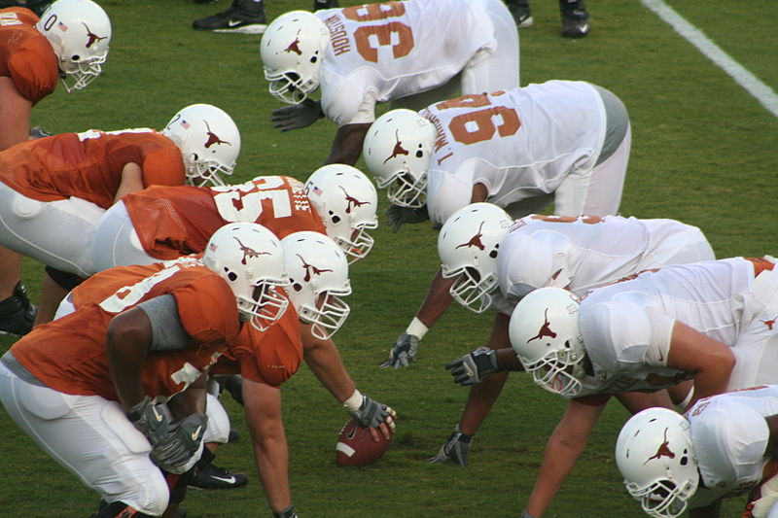

Which of the following would you recommend to players to improve their balance and stability?

* 1. Lower their centre of mass, line of gravity over base of support, increase points of contact.
  2. Raise their centre of mass, line of gravity over base of support, increase points of contact.
  3. Lower their centre of mass, line of gravity outside base of support, increase points of contact.
  4. Lower their centre of mass, line of gravity over base of support, decrease points of contact.

**Short Answer (20 marks)**

**Question 6 (4 marks)**

The bicep curl is a common exercise utilised by weightlifters to gain strength.

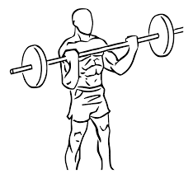

* + - * 1. Using your understanding of levers, label the components of the lever shown in the bicep curl below:

(3 marks)

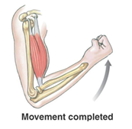

Resistance / Load

(Weight/Dumbbell)

1 mark

Force / Effort

(Biceps muscle)

1 mark

Axis / Fulcrum

(Elbow Joint)

1 mark

* + - * 1. Identify the class of lever you have labelled. (1 mark)

|  |  |
| --- | --- |
| **Identifies** | **Max 1 Mark** |
| 3rd Class Lever | 1 mark |

**Question 7 (4 marks)**

Define the **two** types of balance that a gymnast may display in a beam routine and provide a relevant example for each.

|  |  |
| --- | --- |
| **Answer Description (no mark for identification of types balance)** | **Max 4 Marks** |
| **Static Balance**  The ability to maintain equilibrium when stationary (or similar).  e.g. handstand on beam / arabesque on beam (or similar) | 1 mark  1 mark |
| **Dynamic Balance**  The ability to maintain equilibrium when moving (or similar).  e.g. somersault on beam / jumping on beam (or similar) | 1 mark  1 mark |

**Question 8 (12 marks)**

Sally Pearson competed in the 100 metres hurdles for Australia at the Olympics. The race consists of ten hurdles at a height of 83.8cm placed along a straight course of 100 metres.

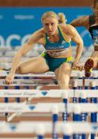

* 1. Using your biomechanical knowledge, identify and define the types ofmotion that Sally Pearson would demonstrate when hurdling. Include a relevant example for her movement.

(8 marks)

|  |  |
| --- | --- |
| **Answer Description** | **Max 8 Marks** |
| **Identifies: General Motion**  **Defines:** Sally Pearson has general motion that is a combination of both linear and angular motion when she hurdles. | 1 mark  1 mark |
| **Identifies: Linear Motion**  **Defines:** Linear motion is when body parts move the same direction at the same time at the same speed (or similar).  e.g. Sally Pearson’s head, torso or trunk all move forwards in a linear motion. | 1 mark  1 mark  1 mark |
| **Identifies: Angular Motion**  **Defines:** Angular motion is when body parts rotate around an axis in a circular motion (or similar).  **e.g.** Sally Pearson’s arms rotate around the axis at the shoulders or legs rotate at the hip axis when hurdling (or similar). | 1 mark  1 mark  1 mark |

* 1. The finish line is 100m from the starting blocks. Define displacement. (1 mark)

|  |  |
| --- | --- |
| **Answer Description** | **1 Mark** |
| Displacement represents the change in position (distance) between the starting point to finishing point (100m). | 1 mark |

Sally Pearson uses pressure sensor angled starting blocks at the start of her 100m hurdles race.

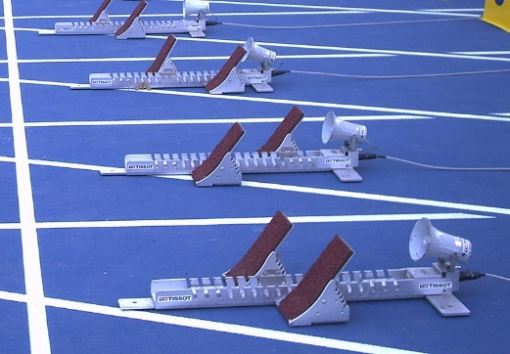

* 1. State Newton’s 3rd Law of Motion and describe how Sally utilises the starting blocks to optimise her start.

(3 marks)

|  |  |
| --- | --- |
| **Answer Description** | **3 Marks** |
| **States:** For every action there is an equal and opposite action. | 1 mark |
| The greater the force Sally applies to the blocks (horizontally), the greater the blocks exert a force against Sally (ground force reaction) propelling her forward more forcefully i.e. a faster start / faster time / greater acceleration. | 2 marks |

**Extended Answer (10 marks)**

**Question 9** (10 marks)

Shot Put involves power, agility and strength to forcefully propel the 7.26kg (male) shot put the greatest distance. The shot is ‘put’ from a 2.13m wide circle with a 10cm high toe-board at the front to assist athletes.

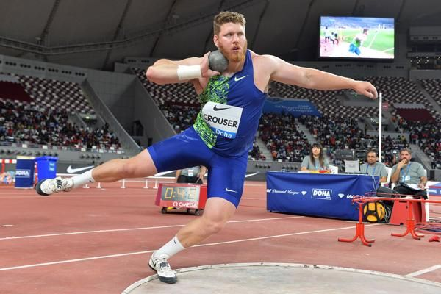

American Ryan Crouser holds the current men’s world record with an incredible 23.37m. Elite shot putters will regularly throw over 20m. Using your biomechanical knowledge of projectile motion, explain how shot putters can achieve maximal distance.

(10 marks)

|  |  |
| --- | --- |
| **Answer Description** | **Max 10 Marks** |
| **Identifies:** Angle, height and velocity of release effect projectile motion. | 1 mark  **(all three)** |
| **Angle of Release**  Angle of release determines trajectory (flight path) of shot put (object/projectile) and horizonal distance achieved. Shot put should be parabolic.  With all other factors constant (velocity/height), angle will determine the time the shot put (object/projectile) stays in the air and the distance travelled.  Optimal angle of release is 45o for maximal distance and flight time if height of release and landing height are the same/equal.  In shot put angle of release can be slightly lower than 45o as height of release is greater than landing height (accept 35o - 40o). | 1 mark  1 mark  1 mark  1 mark  **(3 marks maximum)** |
| **Height of Release**  Height of release determines trajectory (flight path) of shot put (object/projectile) and horizonal distance achieved.  With other factors constant (velocity/angle), the greater the height of release will increase the horizontal distance of the shot put (object/projectile).  In shot put height of release should be raised higher than shoulder (extend arm forwards and upwards over toe plate) to increase horizontal distance achieved.  Taller shot putters have an advantage due to increased height of release. | 1 mark  1 mark  1 mark  1 mark  **(3 marks maximum)** |
| **Velocity of Release**  The velocity of release is the most important factor when maximizing the shot put (object/projectile) distance travelled.  The greater the velocity of release, the greater the distance the shot put (object/projectile) will carry.  The velocity of the shot put (object/projectile) at the time of release will be the most important factor in determining the horizontal distance of the flight path/trajectory as long as all other factors (angle/height) are constant.  Shot putter should try to gain as much velocity as possible across the circle prior to release to attain maximal horizontal distance (through segmental motion). Use toe plate to reduce velocity after release. | 1 mark  1 mark  1 mark  1 mark  **(3 marks maximum)** |

**End of Topic**

**Topic: Sports Psychology (35 marks)**

This section has **10** questions. Answer **all** questions. Answer the five **(5)** Multiple-Choice questions on the separate Multiple-choice answer Sheet provided. Write your answers to the Short Answer and Extended Answer question in the spaces provided in this Question/Answer Booklet. Wherever possible, confine your answers to the line spaces provided. Use a blue or black pen (**not** pencil) for this section.

Spare pages are included at the end of this booklet. They can be used for planning your responses and/or as additional space if required to continue an answer.

Suggested working time: 50 minutes.

**Multiple Choice (5 marks)**

* + - 1. Which of the following statements about arousal is correct?

1. Boxing requires a high level of arousal for optimal performance.
2. Novice performers require a high level of arousal for optimal performance.
3. Archery requires a high level of arousal for optimal performance.
4. Cliff top diving requires a high level of arousal for optimal performance.
   * + 1. A netball player must process the movements and positions of team mates to make a successful pass. The players attentional focus is:
5. Narrow and internal.
6. Narrow and external.
7. Broad and internal.
8. Broad and external.
   * + 1. Marie sets herself a goal to be able to bench press 65kg by the end of her AFLW pre-season. What type of goal is this?
9. Personal goal.
10. Process goal.
11. Outcome goal.
12. Physical goal.
    * + 1. Michael Jordan was one of the greatest basketball players of all time. He was known for his intense focus, internal drive and game winning shots. He was often described as being ‘in the zone’. Which statement best defines being ‘in the zone’?
13. Optimal performance trait.
14. Optimal performance mood.
15. Optimal performance state.
16. Optimal performance self-confidence.
    * + 1. Using selective attention to focus upon relevant stimuli during a tennis rally would benefit performance by:
    1. improving concentration.
    2. controlling arousal.
    3. increasing self-confidence.
    4. reducing stress.

**Short Answer (20 marks)**

**Question 6 (9 marks)**

Setting a specific and measurable goal is important for school students working towards an inter-school athletics competition so they have a time, distance or height to work towards.

* 1. List **five** other characteristics of effective goal setting. (5 marks)

|  |  |
| --- | --- |
| **Identifies** | **Max 5 Marks** |
| Identifies **SMARTER** Goals **(no mark for specific or measurable)**  Action orientated / Agreed  Realistic  Time based  Effective / Exciting  Reviewed / Recorded | 1 mark  1 mark  1 mark  1 mark  1 mark |

* 1. Provide an example of a specific athletics event goal and how a school student would measure their progress towards this as they approach their inter-school athletics competition.

(4 marks)

|  |  |
| --- | --- |
| **Answer Description** | **Max 4 Marks** |
| **Specific:** Goal must state an exact time, distance or height they want to achieve (or similar).  **Example:** sprint 100m in under 13.5s / throw javelin over 20m / long jump over 4m / high jump over 1m40cm  **Measurable:** Time (100m etc.) or measure (throws / jumps) improvement on a weekly (regular) basis to monitor improvement (or similar).  Know personal best and improvement necessary to attain goal (or similar).  Use of performance or process goals to achieve outcome goal (or similar). | 1 mark  1 mark  **(Max 2 marks)**  1 mark  1 mark  1 mark  **(Max 2 marks)** |

**Question 7 (4 marks)**

Motivation is an important factor in the pathway to achieve long term goals. Explain the **two** types of motivation and provide a sporting example for each.

(4 marks)

|  |  |
| --- | --- |
| **Answer Description (no mark for identifying)** | **Max 4 Marks** |
| **Intrinsic Motivation**  The enjoyment / fun / personal satisfaction / internal drive of the player / athlete.  Person centred, driven by internal / intangible rewards from performing the task.  **Or similar wording.**  **Examples:** Setting a personal best / personal fitness / weight loss / social enjoyment / representing country / participation for fun (or similar). | 1 mark  1 mark |
| **Extrinsic Motivation**  The external drive / reasons for competing in sport.  Driven by external / tangible rewards from performing the task.  **Or similar wording.**  **Examples:** Medals / trophies / professional contract / prize money / sponsorship (or similar). | 1 mark  1 mark |

**Question 8 (3 marks)**

Sophie is a 43-year-old who enjoys socially jogging around her local 5km Park Run course with friends each Saturday morning. List **three** factors that influence a person’s choice of involvement and reasons for taking part in sporting activities.

(3 marks)

|  |  |
| --- | --- |
| **Lists** | **Max 3 Marks** |
| Age  Skill level  Type of activity  Motivation | 1 mark  1 mark  1 mark  1 mark  **(Max 3 marks)** |

**Question 9 (4 marks)**

Nideffer’s Model explains the attentional demands athletes require in varying sporting situations. The direction scale relates to whether a player’s focus should be internal or external. Describe the width scale and apply this to a sporting context of your choice.

(4 marks)

|  |  |
| --- | --- |
| **Answer Description** | **Max 4 Marks** |
| **Identifies:** Broad and narrow | 1 mark |
| **Explains:**  **Broad** – attentional focus / concentration is directed towards multiple stimuli / cues. Multiple decisions to process and options / choices to decide upon (or similar).  **Narrow** – attentional focus is directed towards on single stimuli / few cues. Very few decisions to process and options / choices to decide upon (or similar). | 1 mark  1 mark  **(Max 2 marks)** |
| **Application:**  Basketball – passing option in open-play (broad) compared to free throw (narrow).  Netball – passing option in open-play (broad) compared to shot at goal (narrow).  Rugby – passing in open play (broad) to penalty/conversion at posts (narrow).  Australian Football (broad) vs. darts (narrow).  Soccer (broad) vs. archery (narrow).  **(or any similar sporting context or comparison between sports)** | 1 mark  **(Max 1 mark)** |

**Extended Answer (10 marks)**

**Question 10** (10 marks)

Tiger Woods won the US Master Golf Tournament in 2019 after a remarkable comeback from injury. More notably, he won the tournament on the fourth day of play when Francesco Molinari, who was comfortably leading the the tournament, psychologically capitulated in the final nine holes as he was being overcome with pressure!

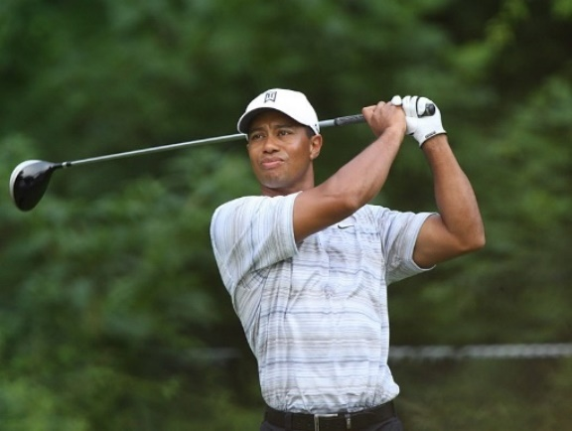

* 1. Draw a fully labelled diagram of the Inverted U hypothesis, placing the points Tiger Woods and Francesco Molinari would be at psychologically, over the last nine holes.

(5 marks)



Francesco Molinari

Tiger Woods

Performance

Arousal

|  |  |
| --- | --- |
| **Labelled Graph** | **Max 5 Marks** |
| Performance (must be Y Axis)  Arousal (must be X Axis)  Arousal curve (even)  Peak of curve – Tiger Woods (optimally aroused)  Right of curve – Francesco Molinari (over aroused) | 1 mark  1 mark  1 mark  1 mark  1 mark |

Tiger Woods body language, facial expressions and demeanour were quite contrasting to Francesco Molinari’s as the pressure intensified and Francesco’s lead diminished.

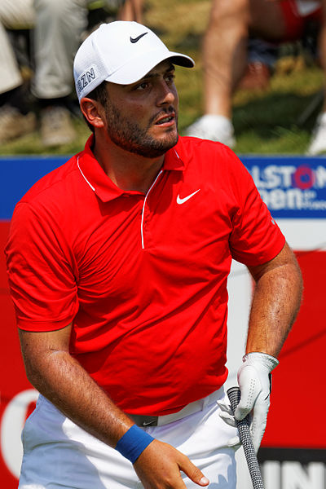

* 1. Compare and contrast **four** differing physiological and psychological symptoms both players would have been experiencing during the final nine holes.

(4 marks)

|  |  |  |
| --- | --- | --- |
| **Player** | **Physiological**  **2 marks (Max 1 for each player)** | **Psychological**  **2 marks (Max 1 for each player)** |
| **Tiger Woods** | * Optimal adrenalin levels * Muscular relaxation allowing fluency and accuracy * Precise coordination (driving) and fine motor control (putting) * Gross motor control * Controlled heart rate and / or respiration rate | * Increased self-confidence * Selectively attend to focus upon relevant stimuli or cues (i.e. the pin / flag) * ‘In the Zone’ – not distracted, blocking out irrelevant information (crowd, score) * Appropriate decision making (e.g. club selection, avoid water) * **No mark for optimal arousal** |
| **Francesco Molinari** | * Increased / elevated heart rate and / or increased respiration rate * Too much adrenaline * Loss of fine motor control * Butterflies / clammy palms * Skill jerkiness / inefficiency * Muscular tension * Gross skill errors * Nausea | * Loss of self-confidence * Unable to selectively attend or focus on relevant stimuli or cues, unable to concentrate * Easily distracted (opposition, score line, crowd, water, bunkers, pressure etc.) * Poor decision making (e.g. club selection) * Increased stress levels * **No mark for over aroused** |

* 1. Francesco Molinari hit numerous shots into water hazards in the final holes of the tournament. The ‘fear of failure’ can become a self-fulfilling prophecy for many athletes that ‘choke’ under pressure. Define the self-fulfilling prophecy.

(1 mark)

|  |  |
| --- | --- |
| **Answer Description** | **1 Mark** |
| The belief / expectation that something positive / negative will happen, it does happen (or similar).  i.e. Francesco Molinari expected a poor shot or the ball to land in the water instead of the green. | 1 mark |

**End of Topic**

**Topic: Motor Learning & Coaching (35 marks)**

This section has **10** questions. Answer **all** questions. Answer the five **(5)** Multiple-Choice questions on the separate Multiple-choice answer Sheet provided. Write your answers to the Short Answer and Extended Answer question in the spaces provided in this Question/Answer Booklet. Wherever possible, confine your answers to the line spaces provided. Use a blue or black pen (**not** pencil) for this section.

Spare pages are included at the end of this booklet. They can be used for planning your responses and/or as additional space if required to continue an answer.

Suggested working time: 50 minutes.

**Multiple Choice (5 marks)**

* + 1. Archery would be best classified as a:

1. fine skill.
2. gross skill.
3. continuous skill.
4. serial skill.
   * 1. Which of the following is an example of an athlete utilising proprioceptive cues to improve performance?
5. A diver adjusting their body position in mid-air to enter the water cleanly.
6. A basketball point guard changing their choice of pass due to player movement.
7. A soccer player passing the ball after a hearing a teammate call ‘man-on’.
8. A golfer changing their choice of club after looking at the distance of the pin (hole).
   * 1. Usain Bolt looking up to see his 100m world record time on the screen would be classified as which type of feedback?
9. Knowledge of performance.
10. Knowledge of result.
11. Concurrent.
12. Positive.
    * 1. A cricket batsman observing the position of the ball in the bowler’s hand and type of release would be at which phase of the Information Processing Model?
         + 1. Identification of stimulus / input phase.
           2. Response identification/decision-making phase.
           3. Response/output phase.
           4. Feedback phase.
      2. The purpose of feedback is to:
13. provide constructive criticism.
14. reinforcement of gross motor errors.
15. increase motivation.
16. reinforcement of fine motor control.

**Short Answer (20 marks)**

**Question 6 (2 marks)**

Elite athletes can use proprioceptive cues or stimuli to detect when they need to modify their skill execution. Identify **two** alternative cues that may be necessary for a young Rugby player just starting to learn the game.

(2 marks)

|  |  |
| --- | --- |
| **Answer Description** | **Max 2 marks** |
| Visual cues  Verbal cues | 1 mark  1 mark |

**Question 7 (5 marks)**

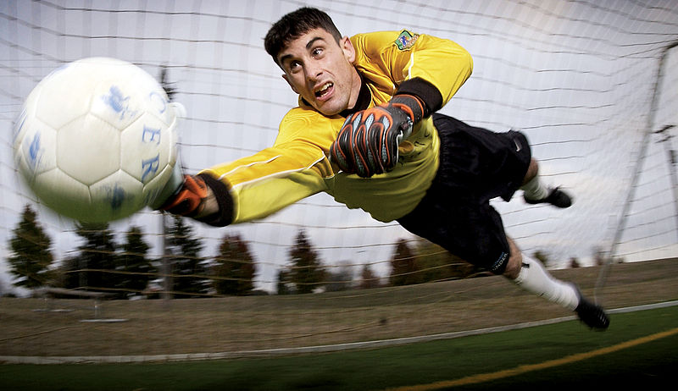Soccer goal keepers must ‘read the play’ and react quickly with the correct decisions to save the ball.

Complete the following flow chart that outlines each stage of the Information Processing Model.

**Input** (1 mark)

Identification of stimulus by sensory system (sight, sound, touch) from environment.

**Response Identification / Decision Making / Processing**

Information analysed, interpreted and a decision or response is selected by brain. (1 mark)

**Output / Response** (1 mark)

Message is sent via central nervous system to muscles and movement is initiated. (1 mark)

**Feedback**

Information about success or outcome of performance is received. Internal or external. (1 mark)

**Question 8 (5 marks)**

* 1. Outline the difference between the following: (2 marks)

Knowledge of Results:

Knowledge of Performance:

|  |  |
| --- | --- |
| **Answer Description** | **Max 2 marks** |
| **Knowledge of Results**  Feedback (objective) that provides the performer with information regarding the success of their performance in achieving a desired outcome. e.g. time / placing / win / loss.  **Knowledge of Performance**  Feedback (subjective) that a performer receives regarding the quality / execution of their movement or technique. | 1 mark  1 mark |

* 1. Identify the **three** purposes of effective feedback. (3 marks)

|  |  |
| --- | --- |
| **Answer Description** | **Max 3 marks** |
| Reinforcement  Improve motivation  Modify future performance | 1 mark  1 mark  1 mark |

**Question 9 (8 marks)**

Skills can be classified and defined by the characteristics they possess. Complete the table below:

|  |  |  |
| --- | --- | --- |
| **Skill Classification** | **Definition** | **Sporting Example** |
| Discrete | The skill has a definite / observable / identifiable start and finish. Must be restarted upon conclusion.  **1 mark** | Swimming dive |
| Gross | The skill utilises large muscle movements that often require power, speed or strength.  **1 mark** | Weightlifting  (or other specific relevant example).  **1 mark** |
| Open  **1 mark** | The skill is performed in a variable / changing environment. | Netball passing in a passage of play |
| Fine | The skill requires small muscle movements requiring accuracy, precision and coordination.  **1 mark** | Pistol shooting |
| Serial  **1 mark** | The skill has a sub-routines that are linked together to form a more complicated skill or entire motor programme. | Triple Jump |
| Continuous  **1 mark** | The skill does not have an easily identifiable / no definite start or finish. No clear beginning and end. The end of one cycle is the beginning of the next.  **1 mark** | Rowing |

**Extended Answer (10 marks)**

**Question 10** (10 marks)

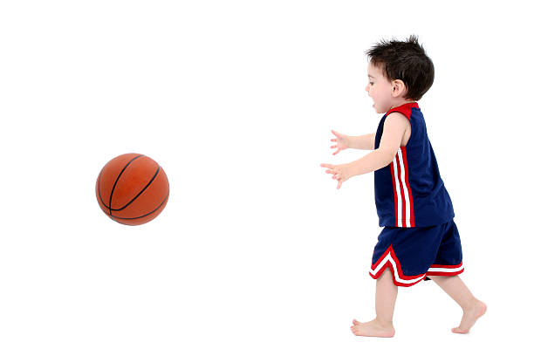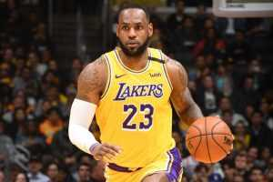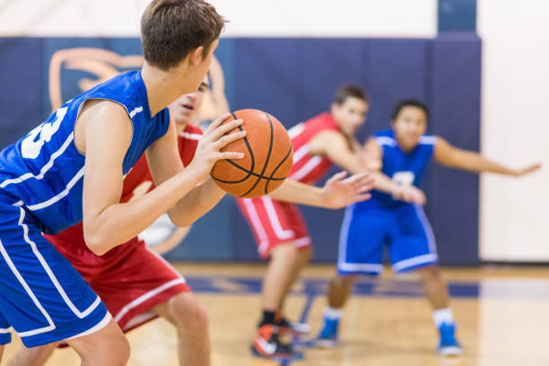

**Image A Image B Image C**

The three basketball players above are at different phases of their basketball experience. The Fitts and Posner Motor Learning Model provides the characteristics of performance within each phase. Identify which image you would expect the basketball player to spend the most time in and explain the characteristics and appropriate type of feedback that should be provided for each phase of learning.

(10 marks)

|  |  |
| --- | --- |
| **Answer Description** | **Max 10 Marks** |
| **Toddler (Image A) Cognitive Phase** | 1 mark |
| **Characteristics**  Large / gross errors made in relation to technique of running, passing, body coordination, positional understanding, rules.  Inconsistent / inefficient / unsuccessful / uncoordinated / jerky skill execution.  Can only focus on limited external stimuli.  No proprioceptive or kinaesthetic awareness or understanding of how the skill feels.  (or other relevant phase characteristics) | 1 mark |
| **Feedback**  Extrinsic concurrent (during), verbal, demonstration (non-verbal). | 1 mark |
| **Teenager (Image B) Associative Stage** | 1 mark |
| Teenager (Image B) Associative Stage phase would be the longest phase of learning. Upwards of to 10,00 hours practice in this phase. | 1 mark |
| **Characteristics**  Learning through use of trial and error.  Error become more inconsistent.  Movement is becoming more efficient / coordinated / smoother / consistent.  Start to develop techniques in varying playing scenarios.  Beginning to identify changes in environment / gameplay situations.  Repeated practice and instruction in refining the skill.  Beginning to develop proprioceptive and kinaesthetic awareness of skills.  Selective attention or cue (stimulus) recognition improves.  (or other relevant phase characteristics) | 1 mark |
| **Feedback**  Extrinsic concurrent (during), augmented (after), verbal, (non-verbal).  Starting to develop their own intrinsic feedback through correct ‘feel’ of the skill. | 1 mark |
| **Professional (Image C) Autonomous Stage** | 1 mark |
| **Characteristics**  Performer’s movements are fluent, accurate and effortless.  Errors are very rare, consistency of success is very high.  Adjusts to constant changing varying environments in gameplay, speed, accuracy and correct decision making (response selection).  Can attend / process to multiple relevant cues (stimuli). Selective attention is high and can avoid distractions.  Skills are executed without conscious thought (automated) from long term memory.  Decision making can focus upon the application of tactics and strategies.  (or other relevant phase characteristics) | 1 mark |
| **Feedback**  Intrinsic (inherent), kinaesthetic, proprioceptive, corrects own errors. | 1 mark |

**End of Topic**

**ACKNOWLEDGEMENTS**

**Functional Anatomy**

Question 8

Image of the Australian Footballer Drop Punt

[**https://en.wikipedia.org/wiki/Punt_(Australian_football)#/media/File:Australian_rules_drop_punt.jpg**](https://en.wikipedia.org/wiki/Punt_(Australian_football)#/media/File:Australian_rules_drop_punt.jpg)

Question 9

Image of Gymnast

[**https://commons.wikimedia.org/wiki/File:2015_European_Artistic_Gymnastics_Championships_-_Rings_-_Eleftherios_Petrounias_03.jpg**](https://commons.wikimedia.org/wiki/File:2015_European_Artistic_Gymnastics_Championships_-_Rings_-_Eleftherios_Petrounias_03.jpg)

**Exercise Physiology**

Question 6

Image of CrossFit Games

[**https://commons.wikimedia.org/wiki/File:2013_CrossFit_Games_-_Stadium_relay.jpg**](https://commons.wikimedia.org/wiki/File:2013_CrossFit_Games_-_Stadium_relay.jpg)

Question 6 (c)

Image of Plank

[**https://commons.wikimedia.org/wiki/File:Plank.jpg**](https://commons.wikimedia.org/wiki/File:Plank.jpg)

Question 6 (c)

Image of Pull Up

[**https://commons.wikimedia.org/wiki/File:Flickr_-_Official_U.S._Navy_Imagery_-_Sailors_work_out_aboard_USS_Green_Bay..jpg**](https://commons.wikimedia.org/wiki/File:Flickr_-_Official_U.S._Navy_Imagery_-_Sailors_work_out_aboard_USS_Green_Bay..jpg)

Question 9

Image of Jai Hindley

[**https://en.wikipedia.org/wiki/Jai_Hindley#/media/File:JaiHindleyGiro2022.jpg**](https://en.wikipedia.org/wiki/Jai_Hindley#/media/File:JaiHindleyGiro2022.jpg)

**Biomechanics**

Question 5

Image of Gridiron Line of Scrimmage

[**https://en.wikipedia.org/wiki/Line_of_scrimmage#/media/File:2006_UT_football_fall_scrimmage.JPG**](https://en.wikipedia.org/wiki/Line_of_scrimmage#/media/File:2006_UT_football_fall_scrimmage.JPG)

Question 6

Image of Bicep Curl

[**https://commons.wikimedia.org/wiki/File:Wide_grip_standing_biceps_curl_with_barbell_2.svg**](https://commons.wikimedia.org/wiki/File:Wide_grip_standing_biceps_curl_with_barbell_2.svg)

Question 6 (a)

Image of Bicep Curl Movement Analysis

**chrome-extension://efaidnbmnnnibpcajpcglclefindmkaj/https://cotswold.gloucs.sch.uk/wp-content/uploads/2018/07/Y11-Summer-Work-PE-2-2018.pdf**

Question 8

Image of Sally Pearson

[**https://commons.wikimedia.org/wiki/File:Sally_Pearson-cropped.jpg**](https://commons.wikimedia.org/wiki/File:Sally_Pearson-cropped.jpg)

Question 8 (c)

Image of Starting Blocks

[**https://en.wikipedia.org/wiki/Starting_blocks#/media/File:PressureSensitiveStartingBlocks.jpg**](https://en.wikipedia.org/wiki/Starting_blocks#/media/File:PressureSensitiveStartingBlocks.jpg)

Question 9

Image of Ryan Crouser

[**https://worldathletics.org/news/feature/ryan-crouser-shot-put**](https://worldathletics.org/news/feature/ryan-crouser-shot-put)

**Sports Psychology**

Question 10 (a)

Image of Tiger Woods

[**https://commons.wikimedia.org/wiki/File:Tiger_Woods_drives_by_Allison.jpg**](https://commons.wikimedia.org/wiki/File:Tiger_Woods_drives_by_Allison.jpg)

Question 10 (b)

Image of Francesco Molinari

[**https://commons.wikimedia.org/wiki/File:Open_de_France_2015_16.jpg**](https://commons.wikimedia.org/wiki/File:Open_de_France_2015_16.jpg)

**Motor Learning & Coaching**

Question 7

Image of Soccer Goalkeeper

[**https://commons.wikimedia.org/wiki/File:Soccer_goalkeeper.jpg**](https://commons.wikimedia.org/wiki/File:Soccer_goalkeeper.jpg)

Question 10

Image A of Basketball Toddler

[**https://www.istockphoto.com/photo/adorable-toddler-boy-playing-basketball-barefoot-over-white-gm96644499-640031**](https://www.istockphoto.com/photo/adorable-toddler-boy-playing-basketball-barefoot-over-white-gm96644499-640031)

Question 10

Image B of Basketball Teenager

[**https://www.istockphoto.com/photo/boys-high-school-basketball-team-gm671176544-122831381?phrase=teenager%20basketball**](https://www.istockphoto.com/photo/boys-high-school-basketball-team-gm671176544-122831381?phrase=teenager%20basketball)

Question 10

Image C of Lebron James

[**https://ourdailynewsonline.com/2020/08/06/lebron-brushes-off-trump-blast-we-could-care-less/lebron_james_lal/**](https://ourdailynewsonline.com/2020/08/06/lebron-brushes-off-trump-blast-we-could-care-less/lebron_james_lal/)

WATP acknowledges the permission of the School Curriculum and Standards Authority in providing instructions to students.